The project I want to make is a platformer, heavily inspired by Celeste. I’ve always been interested in platformers and have made some in the past in Unity, and I’m curious how making it in p5.play would change the process.

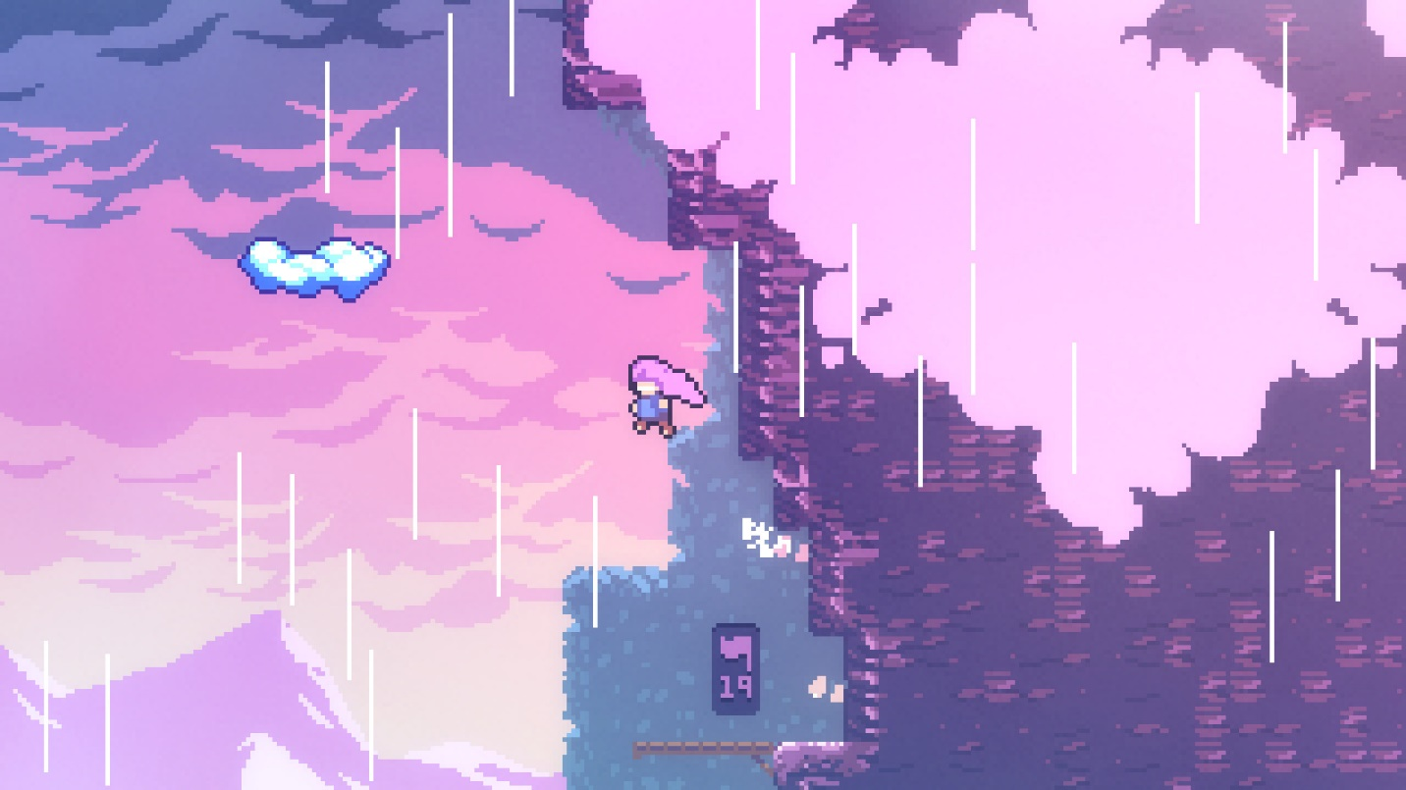

A lot of the inspiration will come from Celeste, a game I have over 1000 hours in. It’s a 2d precision platformer, with a story that is an allegory for the main characters mental health. I’m also hoping my code modding and TASing experience will help me make a good platformer in p5js

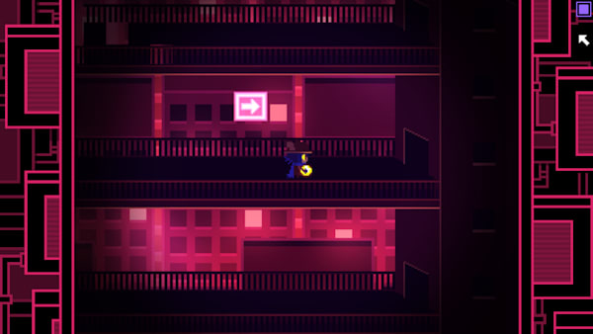

The art style will probably take heavy inspiration from OneShot, which is a top down RPG style game, following a cat called Niko who is thrown into a completely new world. I really like the atmosphere the game executes, with most of the areas being dark and a bit depressing, aside from a town where basically the only other characters live.

I plan on doing a linear level for the game, and hopefully doing multiple levels with some sort of story between them. Main character will probably be a self insert.

The process would be something like this

* Get the character sprite moving, with physics that feel nice to play with
* Get a basic room working, with collision and death triggers
* Hopefully frame the camera in a way where when the player gets to the end of the room, they can walk off the screen and trigger the camera to move to the other room
* Implement keys that you have to pick up and bring to gates, and also switches that you have to hit all of them to open a door
* Possible collectables, like pancakes that don’t serve much of a purpose besides to be something to go for as an extra challenge
* Art for the background will be needed, (I’ll probably default to calling it a Styleground because that’s the term celeste modding uses)
* End screens for each level
* A timer that tracks how long each level took you